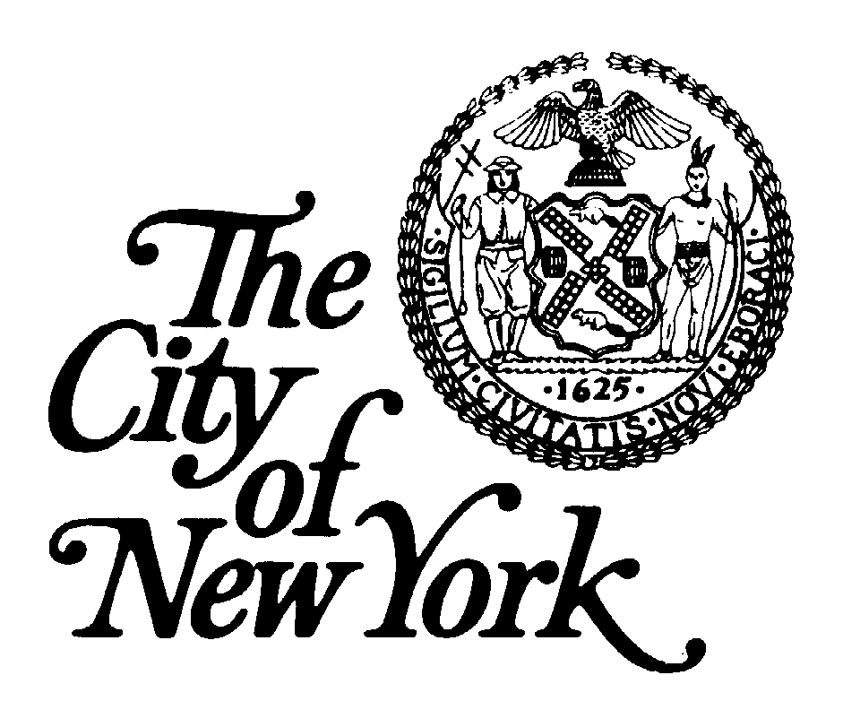 | Brooklyn Community Board 13  1201 Surf Avenue – 3rd Fl., Brooklyn, NY 11224  (718) 266-3001 FAX (718) 266-3920  http://www.nyc.gov/html/bkncb13 | Antonio Reynoso  Borough President  Lucy Mujica Diaz  Chairperson  EDDIE MARK  District Manager
COMMUNITY BOARD 13
BOARD MEETING
MINUTES

Date: Mon., Nov. 21, 2022 Time: 7:00 p.m. Loc.: Zoom

MEMBERS PRESENT:
Lucy Mujica Diaz Zunera Ahmed Lakeisha Bowers
Marion Cleaver Asad Dandia Lolita Divilova
Susan Flaschenberg Olga Fort Erum Hanif
Ronald Greenberg Amarilys Herrera Cynthia Leveille
Yelena Makhnin Allen Newman Pat O’Brien
Robbin Wright Paraison Boris Pincus Milagros Quiles
Nodira Pirmukhamedova Michael Quinn Sam Rinkovsky
Michael Russo Jeff Sanoff Fran Schwartz
Tatyana Segal Pervez Siddiqui Michael Silverman
Pat Singer Evelyn Strasser Jack Suben
Barbara Teitelbaum Fanya Vasilevsky Gregory Vayngurt
Edita Volovodovskaya Gloria Watkins Joann Weiss
Annette Wesley David Wynn Kumali Zairee
Svetlana Zelinskaya
MEMBERS ABSENT:
Dionne Brown Patricia Brown Mario Caggiano(e)
Joe Corace(exc) Selina Grant Queenie Huling
Doyin Isaac Bernard Kaufman Dennis Vourderis
GUESTS:
Alonso Espinoza(Eric Palatnik), Christopher Greif, Eric Palatnik, Craig Hammerman,
BC Michael Mandala, Mark Merynk, Bryan Grimaldi(National Grid), Jacki VanMoer,
Troy Olson(CM Vernikov), Angela Kravachenko, Justin Jarbae, Priscilla Fisk, Ronda Messer(DOT
AM Frontus, Rhonda Rose, Ida Sanoff, Alec Brook Krasny, CM Ari Kagan, Frank Fontana(DOB),
Alec Gurevich(Bklyn D.A.), Rabbi Weiner
OFFICE STAFF PRESENT:
Eddie Mark, District Manager, Lucia Knizhik, Community Assistant, Barbara Santonas, Secretary

Lucy opened the November General Board meeting of Community Board 13 and welcomed everyone to the meeting. She remarked that Mayor Adams had extended the Emergency Order until Dec. 21st, so our December Board meeting will be on Zoom. She further stated that the Board needs to take a vote for how our meetings, both committee and general board, will go forward once the Mayor suspends the Emergency Order.

A Moment of Silence was taken in memory of Alberto Zamperla, owner of CAI Amusements (Luna Park) who passed away suddenly.

Community Board 13 pg 2
Meeting
Minutes
11.21.2022

PRESENTATION: “Climate Action Council” and regarding the law called “The Climate Leadership and Community Protection Act”. Bryan Grimaldi, National Grid

An overview of both the Climate Action Council and the law called “The Climate Leadership and Community Protection Act” was given. (See presentation material attached).

PUBLIC HEARING: ULURP application Block 7237, Lots 61,63,64,65-58 Nixon Court, Brooklyn, New York, as well as Block 7238, Lot 115 (the “Rezoning Area’) near the intersection of Shore Parkway and Ocean Parkway in the Gravesend area of Brooklyn Community Board #13.

Attorney Eric Palatnik reviewed the history of this project. It was originally presented in its preliminary form two years ago. It is across from Coney Island Hospital on Nixon Court, which is in an R5 zone. It needs to be amended to R7X and R7X/C2-4. Also a zoning text amendment would be sought that would make the Rezoning Area applicable as a Mandatory Inclusionary Housing area. The area is also in the Special Ocean Parkway District. This change in zoning would be good for the building next door. It was originally scheduled for a 9 story building, but after discussions with CM Kagan, who explained the need for additional parking spaces, the owner decided to amend the building from 9 stories to 7 stories with a partial 8th floor. It has already been certified with City Planning. The building will have studio, 1 and 2 bedroom apartments with 8 parking spaces. There will also be 800 square feet of commercial space. The floor area will be 17,000 square feet.

Christopher Grief wanted to make sure that the building will be totally accessible. Yelena Makhnin said she did not care about the height of the building, she was just worried about the mandatory inclusionary housing portion. Councilmember Deutsch worked very hard not to include this area in MIH because it meant less parking. Jeff Sanoff wanted to know if this building would be all electric, after hearing what National Grid presented. Mr. Palatnick said it would depend on if the project was completed before the date when all buildings must be completed.
Michael Silverman is concerned that the location is on the side of the Belt Parkway, near the entrance to the Belt going towards the City. He wants to know how will this building and its construction impact on getting onto the Belt. Tatyana Segal stated that it is near a very busy intersection, and also there is no playground or shrubs to make the area more pleasant. Gloria Watkins wanted to know if the building will be under HPD. Mr. Palatnik said it will have a regulatory agreement.

ELECTED OFFICIALS/REPRESENTATIVES:
CM Ari Kagan – The CM wished everyone a Happy & Healthy Thanksgiving. There had been a fire at 2957 W. 33rd St. caused by garbage in the incinerator. Also, a water pipe broke.
AM-Elect Alec Brook Krasny – He said that he had been the AM in the 46th AD and left the office in 2015. At that time his son had a substance abuse problem. He hated to leave the Assembly, he loved the job then and he knows he will love the job now. He is against legalizing marijuana and he wants to work to get the law reversed. Drug abuse will be at the epicenter of his efforts in the community. He is concerned with the needs of all the community. He believes that the community should have a trade school, as a safety issue for children. Not all kids are college bound. (Lucy asked him if he would like to meet during the month of December to get up to speed on the district needs. Alec said he would like that. He wants and hopes for a smooth transition.
Troy Olson-representing CM Vernikov – On behalf of the CM, he wished everyone a Happy & Healthy Thanksgiving. There will be free mammography appointments. Call the office to schedule.

Community Board 13 pg 3
Meeting
Minutes
11.21.2022

Hassaan – representing Brooklyn Borough President Reynoso – He brings regards from Borough Hall. Renewal applications for Community Board members can be submitted via email until February 14, 2023. Application and directions can be found on Borough President’s website.
Lucy said that she will be writing a letter to the BP discussing each member up for reappointment; their attendance etc. She hopes her input will be taken into consideration.
Ida Sanoff – At the October meeting it was announced that the ferry dock would be dismantled. DEC and ACE had not ignored the public, all this would have been avoided and millions of dollars would not have been spent on nothing. The agencies should have accepted the expertise and knowledge of people who live in this community and have been working on this situation for a long period of time.
Frank Fontana – DOB – He is filling in for Ken Lazar tonight. The Department of Buildings have moved their office to 345 Adams Street. He wished everyone a Happy Thanksgiving.
Craig Hammerman – See his statement included in the minutes.
Christopher Greif – On behalf of him and his mother, he wished everyone a Happy Thanksgiving.

MINUTES:
Motion made by Joann Weiss, seconded by Marion Cleaver to approve the minutes as submitted.
VOTE: In Favor: 34 Opposed: 0 Abstention: 0
Motion carried (quorum present). Roll call on file at C.B. office.

CHAIRPERSON’S REPORT:
Lucy stated that Mayor Adams has extended his Emergency Declaration until Dec. 21st. During the meeting we will discuss various ideas for meeting once the Emergency Declaration is lifted. Eddie and Lucy have looked at several new locations for our office.
DISTRICT MANAGER’S REPORT:
Eddie reported that next week there will be a Land Use Committee meeting to approve ULURP for Nixon Court. He attended the Mayor’s Town Hall meeting for Brooklyn which was held at Madison High School. Eddie reported that the street behind the Surf Vets Building on West 21st Street will be raised. More information will be forthcoming. Eddie congratulated the new and re-elected officials. He said the board will reach out to them to discuss the needs of the community.
Eddie thanked PEP officials who intervened with party goers at the Brighton Beach Pavillion who have a party every weekend. Eddie said that hopefully in December there will be a meeting with the city agencies to discuss the rules and regulations for cannabis.

CORRESPONDENCE:
- Wednesday, Nov. 23rd from 12-3:30 there will be a community Thanksgiving Dinner at Garguilio
Restaurant. All are welcomed.
- Monday, Nov. 22nd there will be food distribution at the Coney Island Y from 2:45 p.m. until the food runs out. Please bring your own shopping bags for the groceries.
- The By Law Committee may be reactivated in May or June, after the Borough President submits his reappointment list.

COMMITTEE MEETINGS:
Executive Committee Meeting Lucy Mujica Diaz
There will be Zoo meetings until Dec. 21st . We still must have a plan for when we go into a hybrid/in person meeting situation. When the vote was taken in committee there were 10 in favor of hybrid/in person and 2 opposed. The chairperson will make exceptions on the excuses given by each member. In a hybrid situation, a quorum must be present. If you are excused you can still be part on the Zoom, you will be counted as present, but cannot vote. All committee meetings will be hybrid.

Community Board 13 pg 3
Meeting
Minutes
11.21.2022

Joann Weiss asked for clarification. If the member is part of the committee, but is on Zoom, they will be marked present, but cannot vote. Lucy reminded everyone that at committee meetings, only committee members will be present.
Jeff said he thinks the vote should be “no” on this issue. If the committee meeting is on Zoom, and no quorum, then no business can be done. Eddie agreed with Jeff – a committee that has a small number of members will be a problem getting a quorum. Lucy commented that that she voted no during the committee meeting, but after today, she is changing her vote, and will vote for hybrid/in person meetings. Michael Russo asked if this issue can be revisited next month.(No).
Zunera clarified that if hybrid members on zoom are marked present, and cannot vote. Lolita clarified at committee meetings, only committee members can attend in person.

Evie wanted to know what would happen with snowbirds, like herself. Lucy said those members will be marked “absent”. Jeff said that as a board member the basic responsibility is to be available to vote on issues concerning the community.

Motion made by Lucy, seconded by Jeff to have monthly board meeting in person.
VOTE: In Favor: 25 Opposed: 10 Abstentions: 0
Motion carried (quorum present). Roll call on file at C.B. Office

Motion made by Lucy, seconded by Jeff to have hybrid committee meetings.
VOTE: In Favor: 20 Opposed: 14 Abstentions: 0
Motion carried(quorum). Roll call on file at C.B. office

OLD BUSINESS: None
NEW BUSINESS: None

GOOD & WELFARE:
Eddie stated that there will be Holiday Caroling on Dec. 9th at 5 p.m. It will start at the 60th Pct and end at TD 34. There will be a second date – Dec. 16th at 5 p.m. It will begin at FDNY at Neptune and West 25th St. and continue to PSA1.

On Dec. 17th there will be a parade on Mermaid Avenue between W. 19th St. and W.37th St.

There being no further discussion, motion to adjourn was made at 9:15 p.m.

Barbara Santonas, Secretary

